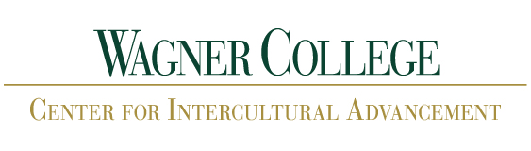

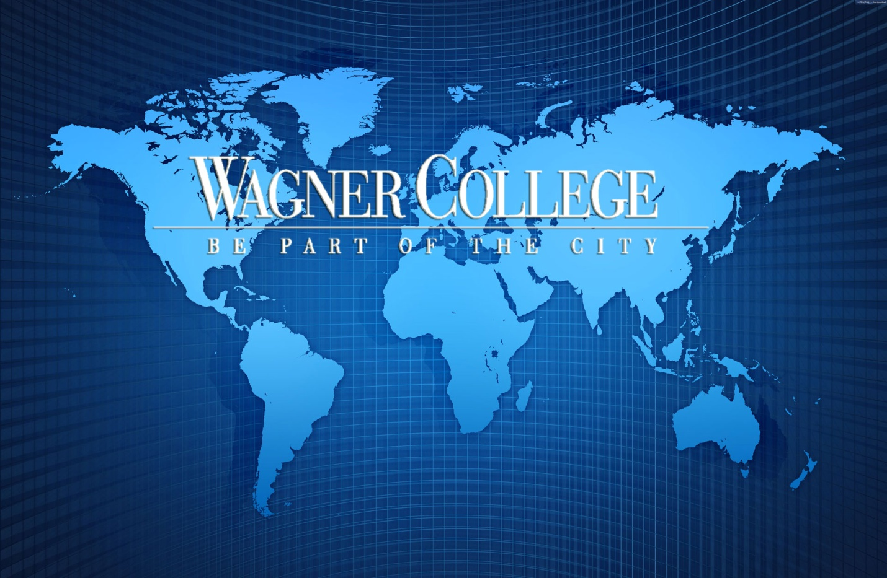

International Student Handbook

2016-2017

**Welcome to Wagner College!**

**This handbook contains important information for students holding an F-1 or J-1 visa.**

One of the first things you should do upon arrival at Wagner is visit your International Student Advisor:

**F-1 and J-1 Visas**

Ellen Navarro, Director

Center for Intercultural Advancement,

Union Building (Room 204)

(718) 420-4517 or [ellen.navarro@wagner.edu](mailto:ellen.navarro@wagner.edu)

Visa officials are referred to as Primary Designated School Official (PDSO) or Designated Officer (DSO) for F-1 visas or Responsible Officer (RO), or Alternate Responsible Officer (ARO) for J-1 visas and are able to sign documents and/or answer your questions regarding visa status and your stay in the United States. A Faculty Advisor will also be assigned to assist you with questions or concerns about your academic program**.**

The Center for Intercultural Advancement supports and promotes Wagner College’s mission statement by creating opportunities for social justice dialogues, sharing information about different cultures, and assisting with the strategic initiatives to internationalize and diversify the campus.

The Center for Intercultural Advancement also provides support for our international students.

The Center serves as a place to obtain information and/or books about internationalization and diversity, a gathering location for formal and informal dialogues and the place for information and advising on studying abroad, whether through Expanding Your Horizons (EYH) programs or semester-long opportunities.

In addition, the Center for Intercultural Advancement houses different organizations, including the Diversity Action Council (DAC) and the Internationalization Action Council (IAC)

You are invited to visit the Center’s website and explore our opportunities. If you have any questions about one of our programs, please don’t hesitate to contact Ellen.

Hours: 8:30 – 4:30 in Union 204

Email: [intercultural.advancement@wagner.edu](mailto:intercultural.advancement@wagner.edu)

Office Phone: 718-420-4532

**Contents**

**Campus Offices and Information**………………………………………………………………………….……………………… 4

**Clubs and Organizations**……………………………………………………………………………………….……………………… 7

**INTRODUCTION TO SEVIS**…………………………………………………………………………………………………………….10

**HOW DOES SEVIS WORK**...................................................................................................................10

**WHAT DATA DOES SEVIS COLLECT?**..................................................................................................11

**WHAT DOES “FAIL TO MAINTAIN STATUS” MEAN?**.........................................................................11

**WHAT ARE THE CONSEQUENCES OF FAILING TO MAINTAIN STATUS?**...........................................11

**CAN A STUDENT WHO IS “OUT OF STATUS” REGAIN LEGAL STATUS?**............................................11

**HOW WILL WAGNER COLLEGE HELP STUDENT COMPLY WITH IMMIGRATION LAWS?**..................12

**WHAT SHOULD STUDENTS DO TO HELP MAKE SEVIS AT WAGNER RUN SMOOTHLY**....................12

**DOES SEVIS BENEFIT STUDENTS IN ANY WAY?**...............................................................................13

**WHAT SHOULD STUDENTS DO TO HELP MAKE SEVIS AT WAGNER RUN SMOOTHLY?**..................13

**General Guidelines**……………………………………………….…………………………………………………………………….14

**KEEPING YOUR STAY IN THE USA LEGAL** …………………………………………………………………………………….16

**TRAVEL & REENTRY**………………………………………………………….………………………………………………………...18

WHAT DO YOU NEED?.........................................................................................................18

ARE YOUR DOCUMENTS VALID? …………………………………………………………………………………….18

HOW IS YOUR FORM I-20 ENDORSED?................................................................................18

**HOW TO RENTER THE U.S. AFTER TRAVELING?**...............................................................................19

**HOW TO RENEW**………………………………………………………………………………………………………………………….20

WHAT ARE THE RULES?........................................................................................................20

ARE YOU PREPARED?............................................................................................................21

**CHANGE OF ADDRESS**…………………………………………………………………………………………………………………..22

**F and J VISA CONTACT INFORMATION**…………………………………………………………………………………………22

**APPLYING FOR YOUR SOCIAL SECURITY NUMBER**...........................................................................23

HOW DO YOU APPLY?...........................................................................................................23

WHERE IS THE OFFICE?.........................................................................................................23

**ON CAMPUS EMPLOYMENT**..............................................................................................................24

WHAT IS IT?........................................................................................................................... 24

WHO IS ELIGIBLE?..................................................................................................................24

HOW DO YOU APPLY?........................................................................................................... 24

WHERE ARE THE JOB LISTINGS FOR ON-CAMPUS EMPLOYMENT?.......................................24

**REQUIREMENTS FOR MAINTAINING F-1 STUDENT STATUS**………………………………………………………….25

**FULL COURSE STUDY**……………………………………………………………………………………………………………………. 26

**Campus Offices and Information**

**Emergency Information & Snow Line: (718) 390 3400**

Center for Academic & Career Development – (718) 390-3416

Athletics – (718) 390-3433

Bookstore – (718) 390-3469

Business Office – (718) 390-3112

Career Development and Experiential Learning – (718) 390-3181

Dean of Campus Life – (718) 390 3423

**Center for Intercultural Advancement – (718) 420-4532**

***Ellen Navarro (Director) – (718) 420-4517***

Chaplain – (718) 390-3281

Co-Curricular Programs – (718) 420-4257

Coffeehouse – (718) 390-3264

Copy Center – (718) 390-3101

Counseling Services – (718) 390-3354

Dining Services – (718) 420-4275

Financial Aid – (718) 390-3158

Health Services – (718) 390-3158

Information Technology (Help Desk) – (718) 390-3410

Library (Horrmann Library) – (718) 390-3401

Postal Center – (718) 390-3128

Registrar – (718) 390-3173

Residential Life – (718) 390-3420

Public Safety & Security – (718) 390-3165

Main Entrance Gate – (718) 390-3148 (**24 hours**)

# [Campus Map](http://wagner.edu/about/visit/campus-map/" \l "sidebar-main)

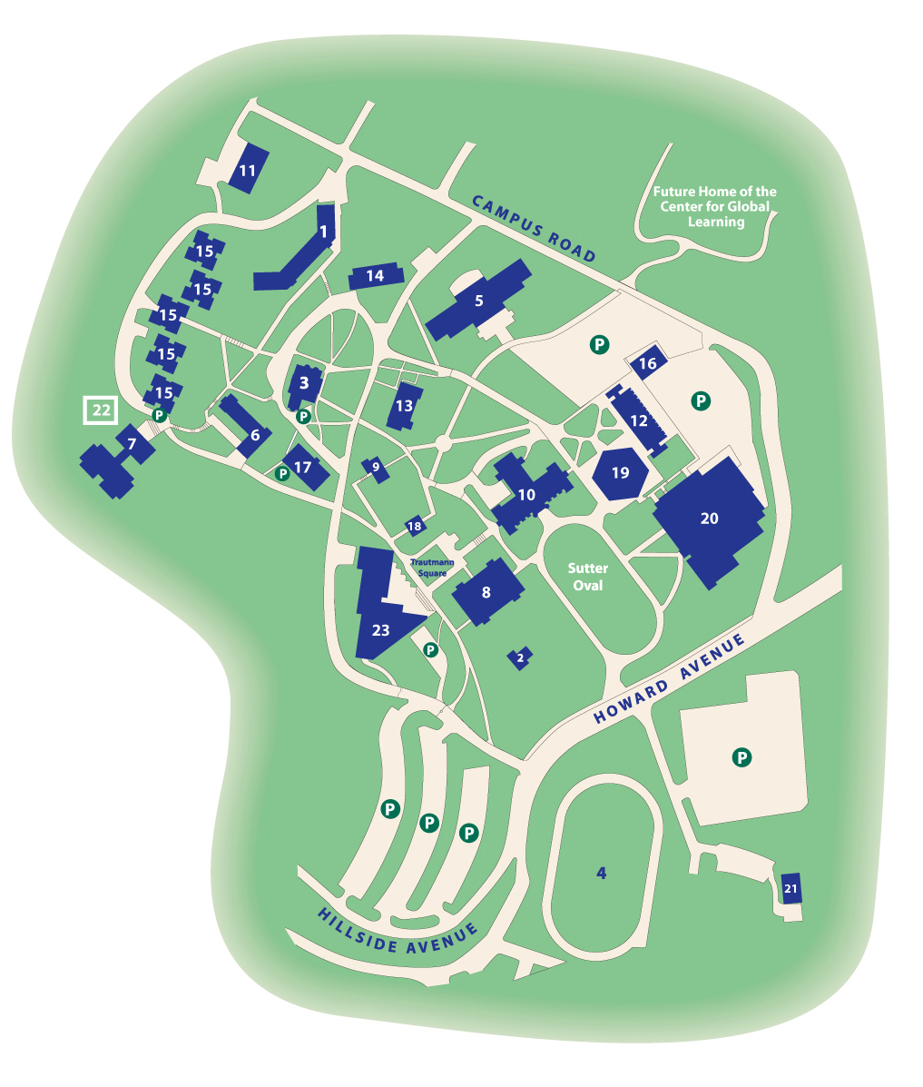

P — Parking  
1 — Campus Hall  
2 — Chaplain’s House  
3 — Cunard Hall  
4 — Football and Track Field  
5 — Foundation Hall  
6 — Guild Hall  
7 — Harborview Residence Hall  
8 — Horrmann Library  
9 — Kairos House  
10 — Main Hall  
11 — Maintenance Shop

12 — Megerle Science Hall  
13 — Pape House (Admissions)   
14 — Parker Hall  
15 — Parker Towers Residence Hall  
16 — Power Plant  
17 — Reynolds House (Alumni)   
18 — Security Building  
19 — Spiro Hall  
20 — Spiro Sports Center  
21 — Stage I Theater  
22 — Tennis Courts  
23 — Union Building

**Clubs and Organizations**

*CLUB FAIR is held during New Student Orientation on the Oval*

Academic Honor Societies

Alpha Mu Theta (Arts Administration Honor Society)

Beta Beta Beta (Biological Honor Society)

Kappa Delta Pi (International Honor Society)

Kappa Mu Epsilon (Math Honor Society)

Kappa Pi (Art Honor Society)

Omicron Delta Kappa (ODK, National Leadership Honor Society)

Omicron Delta Epsilon (ODE, International Honor Society for Economics)

Psi Chi (International Society in Psychology)

Psi Epsilon (Biopsychology Honor Society)

Sigma Tau Delta (International English Honor Society)

Arts Groups

Art Club

Art for a Cure

Business

Club for International Business Strategies Studies

Marketing Club

Pre-Law Society

Coterie Writing Club

Greek Life

*Fraternities:*

Alpha Phi Omega (APO, National co-ed Service Fraternity)

Delta Nu (DNu, Local Social Fraternity)

Kappa Sigma Alpha (Local co-ed Social Fraternity)

Tau Kappa Epsilon (TKE, International Social Fraternity)

Theta Chi (International Social Fraternity)

*Sororities:*

Alpha Delta Pi (ADPi National Social Sorority)

Alpha Omicron Pi (AOPi, International Social Sorority)

Alpha Sigma Alpha (ASA, National Social Sorority)

Tau Kappa Sigma (TKS, Local Social Sorority)

*Governing Boards:*

Greek Senate

Inter-Fraternity Council (IFC)

Panhellenic Council

Lifestyle:

Allies/Gay Straight Alliance

Asian American Student Association

Hillel Club

History Club

Interfaith

Intercultural Connections Club

Muslim Student Association (MSA)

Nubian Student Union (NSU)

Philosophy Café

SAAC (Student Athlete Advisory Council)

Student Government Association

The Red Riding Hood Project

USITT (United States Institute for Technical Theatre)

WagCAB (College Campus Activity Board)

Wagner College Republicans

Performance

Completely Student Production (CSP)

SAAS (Society of Arts Administration Students)

SRMT (Student Run Musical Theatre)

Philanthropy & Service

Amnesty International

Colleges against Cancer

Habitat for Humanity

Project Sunshine

Promising Student Society

Unified Theater

Up ‘Til Dawn

American Association of University Women (AAUW)

Christian Fellowship

Commuter Student Association

Publications

Kallista Yearbook

Nimbus

Wagnerian (College Newspaper)

Recreational

Dance Club

Field Hockey (Recreational Team)

Gymnastics (Recreational Team)

Intramural Sports

Sciences

Biology Club

Microbiology Club

PAA (Physician Assistant Association)

Pre-Dentistry Society

Pre-Health Society

Psychology Club

SNA (Student Nursing Association)

Sociology Club

**INTRODUCTION TO SEVIS**

**WHAT IS IT?**

“SEVIS” stands for the Student and Exchange Visitor Information System. It is a secure internet-based system that allows schools and the United States Citizenship and Immigration Services (USCIS, formerly INS) to exchange data on the visa status of international students. Accurate and current information is transmitted electronically throughout an F-1 student’s academic career in the United States. The International Student Advisor, known to USCIS as the Designated School Official (and referred to in this memo as the DSO) is responsible for reporting this information in SEVIS. United States embassies and consulates also have access to SEVIS.

**IS SEVIS NEW?**

Yes and no. The requirement that schools provide the federal government with information about each student’s status is not new. The INS (now USCIS) has for many years required most of the information that will be reported to SEVIS. But the existing paper-based system did not allow widespread coordination between schools and governmental agencies. In 1996, Congress passed legislation directing the INS to move to an electronic data collection system. Technical challenges and lack of funding delayed the program for several years. However, in October of 2001 Congress passed the USA Patriot Act that authorized additional SEVIS funding and required nationwide compliance by January 30, 2003.

**HOW DOES SEVIS WORK?**

* After Wagner College admits an international student, SEVIS is notified and USCIS approves the College’s request to issue an I-20. The Center for Intercultural Advancement prints and issues the new bar-coded I-20 form to the student. Students already attending Wagner have been issued I-20s by the DSO.
* The student visits the U.S. consulate abroad, and the consulate confirms that the I-20 the student is carrying is a valid document. If everything is in order, the consulate issues the visa.
* A USCIS officer at the airport reports to SEVIS the student’s entry to the U.S. When the student arrives on campus, he/she reports to the International Student Advisor, (DSO) who confirms through SEVIS the student’s enrollment.
* The College continues to provide regular electronic reports to USCIS throughout the student’s academic career.
* Finally, SEVIS records the student’s departure from the United States.

**WHAT DATA DOES SEVIS COLLECT?**

Wagner College must report:

* Whether the student has enrolled at the school or failed to enroll.
* A change of the student’s or dependent’s legal name or address.
* Any student who graduates prior to the end date listed on the I-20.
* Academic or disciplinary actions taken due to criminal conviction.
* Whether the student drops below a full course of study and the authorization for it from the DSO
* Termination date and reason for termination.
* Other data generated by standard procedures such as program extensions, school transfers. Changes in level of study, employment authorization and reinstatement.
* Any student who fails to maintain status or complete his or her program.

**WHAT DOES “FAIL TO MAINTAIN STATUS” MEAN?**

Some examples of failure to maintain status include dropping from full-time to part-time enrollment without prior approval from the DSO, attending a school other than the one a student is authorized to attend, failure to apply for a timely transfer from another U.S. school to Wagner College, failure to apply for an I-20 extension or change in level of study, unauthorized employment, and failure to report a change of address.

**WHAT ARE THE CONSEQUENCES OF FAILING TO MAINTAIN STATUS?**

The student’s record will be updated in SEVIS every semester. Students who fail to maintain status lose the privileges of their student visa and become subject to deportation. Specific consequences may include denial of re-entry to the U.S., inability to move from undergraduate to graduate status, denial of requests for Optional Practical Training (OPT), denial of requests to change visa status, and possible denial of future visa applications.

**CAN A STUDENT WHO IS “OUT OF STATUS” REGAIN LEGAL STATUS?**

If a student drops below a full course of study without prior approval from the DSO, that “event” would be reported to USCIS via SEVIS, and he or she would be out of status. The student may apply to USCIS for reinstatement if the violation resulted from circumstances beyond his or her control. Reinstatement is intended to be a rare benefit for exceptional cases. If USCIS does not reinstate the student, he or she may not appeal that decision.

**HOW WILL WAGNER COLLEGE HELP STUDENT COMPLY WITH IMMIGRATION LAWS?**

Wagner College is committed to assisting students in preventing status violations from occurring. Accordingly, these policies are in effect:

1. Throughout the registration period, the DSO will monitor the enrollment of international students. “Full time” means 4 units per semester for undergraduates, and 9 credits for graduate students. *International students may not register for less than full time without approval from the DSO.*
2. International students must not drop below a full course of study *after* classes have begun without prior authorization from the DSO. *A student who is authorized for a reduced course load must enroll in at least 2 units.*

Acceptable reasons for a reduced credit load include:

* Students who experience academic difficulties (for example, unfamiliarity with America’s teaching methods or English language difficulties) may take a reduced course load. Students are allowed to drop below full time for academic difficulties only once during their degree program. Documentation from the faculty advisor is required.
* Graduate students who have completed required coursework may register for thesis or dissertation credit only. Graduate assistants may register for six credits instead of nine. Documentation from the appropriate supervisor is required.
* Students in their final term of study need only to register for the course hours required to complete the degree. Documentation from the faculty advisor is required.
* Students who have a medical problem can reduce their course load. Documentation from a licensed physician or psychologist is required.

Remember: only the DSO has the authority to approve a reduced course load. This approval must be obtained before dropping below full time status.

**DOES SEVIS BENEFIT STUDENTS IN ANY WAY?**

Data moves faster through an electronic system than through a paper system. Students can expect that USCIS forms will be produced faster, applications for benefits such as Optional Practical Training will be approved more quickly, and visas will be granted without long delays.

**WHAT SHOULD STUDENTS DO TO HELP MAKE SEVIS AT WAGNER RUN SMOOTHLY?**

* Check your Wagner email account, voicemail and mailbox regularly
* Understand the immigration regulations and learn how to maintain lawful status in the U.S., and refer any questions or problems immediately to the DSO
* Be proactive---plan your course schedule carefully and make an appointment with your faculty advisor in order to register during the proper registration period
* Make travel arrangements early and be sure you have a current, valid signature on page 3 of your I-20. Come to the DSO a week before traveling if a new signature is needed
* Keep all documents up-to-date. Changes in program level or major, extension of program, change of address and other authorizations must be made in a timely manner and on SEVIS documents. Allow time for processing new forms
* Be sure that your finances are in order. You will not be able to register for classes if you have an outstanding tuition balance
* If you do not register for classes for a fall or spring semester, you are required by USCIS regulations to depart the United States

Ellen Navarro, PDSO, ARO

Director, Center for Intercultural Advancement

ellen.navarro@wagner.edu 718-420-4517

**GENERAL GUIDELINES**

1. Whenever you need advice concerning your non-immigrant status and rights and responsibilities within the U.S., be sure to consult with the Designated School Official, **first!!!** Friends and other sources who may seem to have correct information, often do not. Each person’s situation is different. It is important to contact the International Student Advisor directly when you need information regarding your non-immigrant status.
2. **When you plan to travel, be sure the ISA/DSO signature on page 2 of your I-20 is still valid. Make an appointment with the Designated School Official to discuss your travel plans by calling 718-420-4523. Take your Form I-20 and passport with you when you travel within the United States, even though you are not leaving the country.**
3. Always bring your passport, I-94 card and Form I-20 when you come for an appointment with the Designated School Official
4. Please schedule your appointment in advance so that we can serve you in a fair and timely manner. When you arrive for your scheduled appointment, please tell the Graduate Assistant.
5. The Designated School Official has a legal obligation to respond to United States Citizenship and Immigration Service (USCIS) inquires about your continued attendance at Wagner College. If you decide to leave the College (transfer, leave of absence), change degree or major, or apply for a change of status, it is your responsibility to notify the Designated School Official. This information must be entered into the SEVIS system by the DSO and a new Form I-20 must be printed.
6. Be aware of Wagner College General Education Requirements. These are the core requirements that *all* students at Wagner College must take. To be considered a student who is following a full course of study, as required by your F-1 visa status, you must take the General Education courses as well as your major courses. A major must be declared by the end of your sophomore year (second year).
7. You must notify the Designated School Official of any change of address or phone number within one week of the change. Be sure to notify the Business Office and the Registrar’s office as well, which are located in Cunard Hall.
8. **Keep all of your immigration papers in a safe place, *including all Forms I-20 from other schools you have attended in the U.S.*** You will need copies of them when you apply for benefits such as employment authorization.

**KEEPING YOUR STAY IN THE USA LEGAL**

It is extremely important to maintain status while at Wagner College. Failure to maintain the terms and conditions of nonimmigrant status is a ground for removal from the United States (deportation).

1. Make sure that your passport does not expire. If it will be expiring soon, contact your consulate in New York City or the embassy in Washington, D.C. for the procedure to extend it.
2. Make sure that you have been authorized to attend Wagner College under the F-1 regulations. This means that you did one of the following:

* Entered the USA with a Wagner Certificate of Eligibility (Form I-20) and it was stamped by the United States Citizenship and Immigration Service (USCIS) *or*
* You transferred with the approval of the USCIS and the International Student Advisor at Wagner College, *or*
* You changed your student visa status.

1. Register for a full-time course load (4 or 5 units) each semester. If you have completed all of your course work and are pursuing your project or thesis, the Designated School Official needs a written statement of your “Full Time Equivalency” from your academic department. If you are unable to attend full time because of medical reasons, you need to complete a Leave of Absence form with Ellen Navarro, the Primary Designated School Official.

*If you are registered for fewer than 4 units for any reason,* you must submit an “Application for Exception to the Full Course of Study” in the Center for Intercultural Advancement.

FAILURE TO DO SO IS A VIOLATION OF YOUR STUDENT VISA STATUS AND WILL RESULT IN BECOMING OUT OF STATUS with the USCIS.

1. If you will not complete your studies by the date stated on your Form I-20, you must apply to your ISA/DSO for a Program Extension at least 30 days before the stated completion date.
2. If you wish to change your major or program level, contact your International Student Advisor.
3. If you have transferred to Wagner from another college, be sure to follow through with any transfer instructions given to you by the Designated School Official within fifteen days of starting classes.
4. **Do not begin any job without written work authorization** from Wagner College or the USCIS. Also, if the work permission is limited to part-time, you may not work over 20 hours per week. See your Designated School Official for details.
5. Do not get immigration-related advice from newspapers, friends, or fellow students. If your DSO cannot help you, you will be referred to the appropriate source.
6. The USCIS allows you to stay 60 days after completion of studies or authorized practical training. You must depart the U.S. within that time period to avoid a violation of F-1 status.

***If any of the above is not clear, please contact the Designated School Official for more information***

**TRAVEL & REENTRY**

**WHAT DO YOU NEED**

Whenever you wish to leave the U.S temporarily (five months or less) and return to continue studies at Wagner College, you must secure the necessary documents to permit entry to another country and reentry to the U.S. You will probably be allowed to enter your country of citizenship or permanent residence with just your valid passport, but to reenter the U.S. there are certain papers you must have

You must present to the USCIS officials at your port of entry the following documents:

* A valid passport with a valid visa
* Your form I-20 endorsed by the PDSO or DSO

**ARE YOUR DOCUMENTS VALID?**

If your visa has expired, you will need a new one to return to the U.S. This can only be issued in your country. You will need a new Form I-20 to renew your visa.

If there has been a substantial change in your situation, such as a change of major or change in financial support, you will need a new Form I-20.

If you have applied for employment authorization (EAD), you may not travel until you have received the authorization card and have a job to return to. You will need to show a letter from your employer to reenter the U.S.

**HOW IS YOUR FORM I-20 ENDORSED?**

A week before you plan to travel, contact the Center for Intercultural Advancement at international.advancement@wagner.edu, or by calling at 718-420-4517, or by stopping by the Union building room 204 to make an appointment.

### 

### HOW TO REENTER THE U.S. AFTER TRAVELING

**MAKE SURE YOU DO NOT HAVE ANY DIFFICULTY RETURNING BY HAVING ALL THE DOCUMENTS YOU NEED TO REENTER! CHECK THE LIST BELOW AND MAKE SURE YOU HAVE EVERYTHING READY BEFORE YOU LEAVE.**

* *A valid passport (unless you are exempt from passport requirements).*
* *A valid F-1 visa. You must have a valid F-1 visa in your passport. There is one exception to this requirement: if you are maintaining F-1 status and are returning to the U.S. after a trip of less than 30 days to Canada, Mexico, or adjacent islands in the Caribbean, you do not need to have a valid visa to return. Instead of the valid visa, you must have the Form I-94 Departure Record stapled in your passport.*

If you entered the U.S. in another nonimmigrant classification and changed your status to F-1, *you must obtain an F-1 visa before reentering from any country except a neighboring country. It is not possible to obtain a new visa inside the U.S.*

If you need a new F-1 visa to reenter the U.S. *after a temporary absence, you will need to get a new Form I-20 from the International Student Advisor office and apply for the visa at a U.S. embassy or consular office in your country of permanent residence. To get a new Form I-20 you must file an application and submit current evidence of your financial support to the International Student Advisor at least two weeks before your departure.*

* *A Form I-20. Make sure that your program of study is still correct and that the date you are expected to complete your program has not expired. You must have a valid reentry signature on page 3 to reenter. Bring your Form I-20 to the International Student Advisor at least three days before your departure.*

If you are starting a new degree program, your completion of study date has passed, or you need to get a new visa, *you will need to get a new Form I-20 from the International Student Advisor. File an application and submit current evidence of financial support at least two weeks before your departure*.

* *Financial documents. If you are going to apply for a new visa from the American embassy or consulate at home, you will need to have original financial documents, not photocopies.*

**HOW TO RENEW YOUR STUDENT VISA**

In most countries, in order to renew your student visa to the United States to attend Wagner College, you must make an appointment with your nearest American embassy or consulate.

Before you apply for the visa renewal, you should understand the process and rules governing the renewal of a U.S. visa. Please read the following information very carefully and contact the International Student Advisor if you need more information or help.

### WHAT ARE THE RULES?

1. *By law, you are seen as someone who plans to remain in the U.S. permanently*. The consul MUST, by U.S. law, believe that you are *not* coming back home when you finish your studies. Student visas are only given to persons who can *convince* the consul that they intend to return permanently to their home country. You convinced the consul once, so the process should be easier the second time!

*You should not attempt to renew a visa if you are on authorized F-1 optional practical training after completion of studies* since it is harder to convince the consul you will return home.

1. *You must prove that you are making normal full-time progress* toward completing the educational or professional objective that brought you to the U.S. and can still finance it.
2. *Consuls are impersonal when administering laws.* In the U.S., laws are applied equally to all people regardless of status or gender. DO NOT TRY TO NEGOTIATE OR DISCUSS PERSONAL MATTERS with the consul.
3. *U.S*.*Government officials like documents.* Have papers available to submit to the consul that prove why you are qualified to renew your student visa.

### ARE YOU PREPARED?

Take either your current Form I-20, endorsed for reentry (or if there has been any *significant change* in the information on it, a *new* one), valid passport, and all new evidence of financial support.

1. Be ready to prove that you have been a full time student and are making normal progress toward completing the educational or professional objective that brought you to the U.S. Plan to account for *all* the time since your last visa interview.

* Take transcripts from *every* school you have attended in the U.S.
* If full-time study is not clear from the transcript, get a letter from the International Student Advisor certifying that you were maintaining your student status.
* Did you change your major? Be prepared to describe your career opportunities *back home.*
* Did you attend the school that appears on your last student visa? If not, be prepared to explain why not. If the new school was at a higher academic level, emphasize it.
* Did you pursue the program of study that was approved during your last visa interview? If not, be prepared to explain why not and how the new program prepares you for a career at home.

1. Be ready to convince the consul that you will return home permanently after you complete your studies. Present papers that can prove that you still have strong ties to your country that will *force* you to return.

* Show how you have been making regular trips back home. If you haven’t, explain why: going to summer school to finish sooner; family comes to visit here.
* If your program of study is in great demand in your country, get a letter from a possible employer saying that they are interested in hiring people with degrees like the one you will earn.
* If your family owns a business, take a letter from the bank describing it. If they own property, take the deeds.

1. Do not emphasize any ties you have to the U.S. or to family members in the U.S.
2. Do not talk about working in the U.S. unless you have an assistantship or fellowship or have employment authorization from USCIS.

**CHANGE OF ADDRESS**

USCIS requires notification of a change of address within 10 days of that change.

You must complete a USCIS change of address card, available on the International Student website and the Designated School Official’s Office. Please notify the DSO within 5 days so that the form will reach USCIS within 10 days.

**F AND J VISA CONTACT INFORMATION**

Ellen Navarro

Director of Intercultural Advancement & Responsible Officer

PDSO & ARO

Union Building

Room 204

Phone – (718) 420-4517

Email – ellen.navarro@wagner.edu

**APPLYING FOR YOUR SOCIAL SECURITY NUMBER**

**HOW DO YOU APPLY?**

To apply for a Social Security number you must appear in person at the Social Security Office and complete an application form (available only at the Social Security Office). Take with you the following items:

* A letter from the prospective employer stating a job offer, including description of position, hours, and salary *or a* letter from your department stating a graduate assistantship
* Your valid passport
* Your valid I-94 (small white card in passport)
* Your Form I-20
* A letter from the International Student Advisor verifying your status as an F-1 student
* A copy of your class schedule

If you are authorized for optional practical training, academic training or off-campus work permission based on economic necessity, you should present your Employment Authorization Document (EAD card). If you are authorized for F-1 curricular practical training, you should present your Form I-20 endorsed for curricular practical training.

It may take about six weeks to receive your card in the mail. When you apply, you will receive a receipt from the Social Security Office. You should keep this receipt as proof of your application for a number.

*Please be aware that a Social Security Number does NOT authorize you to accept employment off campus. Permission to accept off-campus employment can only be granted by USCIS.*

### WHERE IS THE OFFICE?

The Social Security Office is located at:

1510 Hylan Boulevard 2nd FL

Staten Island NY 10305

Telephone: 1-800-772-1213

It is open 8:30 a.m. – 4:00 p.m., Monday through Friday

If you wish to obtain a driver’s license or register a motor vehicle in New York State, you will be required to provide a social security number or a letter from the Social Security Administration stating you are ineligible for a social security number. Their office on Hylan Boulevard will provide the required letter upon request.

**ON CAMPUS EMPLOYMENT**

### WHAT IS IT?

On-campus employment is working directly for an office at Wagner College (such as your academic department or library) or working for a commercial firm located at Wagner College that provides direct services to the students. In these situations you may not displace a United States resident. On-campus employment also includes graduate assistantships, such as teaching or researching within your department.

### WHO IS ELIGIBLE?

#### As an F-1 student, you may apply for permission to work on campus (at Wagner College) provided you have been authorized to attend Wagner College by the United States Citizenship and Immigration Service (USCIS) and are pursuing full-time studies at Wagner College. There is no minimum time requirement in the United States. You will need a Social Security number in order to be paid for on-campus employment.

### HOW DO YOU APPLY?

Apply through the Financial Aid Office, located on the second floor of Cunard Hall.

### WHERE ARE THE JOB LISTINGS FOR ON-CAMPUS EMPLOYMENT?

They are located in the Financial Aid Office and on their website page:http://wagner.edu/financial-aid/

**REQUIREMENTS FOR MAINTAINING F-1 STUDENT STATUS**

1. **Pursue a full course of study at the authorized school** [8 CFR 214.2 (f)(5)(i)].
2. **Complete the school transfer procedure to change authorized schools or continue from one educational level to another at the same school** [8 CFR 214.2(f)(5)(ii) and –(8)].
3. **Obtain a program extension to remain longer than the time originally estimated on the Form 20 A-B** [8 CFR 214. 3(f)(5)(iii)].
4. **Obtain authorization to work off campus and work as authorized** [8 CFR 14.2(f)(9)(ii)(A) and (10)]
5. **Work on campus as authorized {8 CFR 214.2(f)(9)(i)].**
6. **Depart the U.S. within 60 days of completion of studies or authorized practical training** [8 CFR 214.2(f)(5)(i)].

**FULL COURSE OF STUDY**

**8 CFR 214.2(f)(6)**

[A] "Postgraduate study or postdoctoral study or research at a college or university, or undergraduate or postgraduate study at a conservatory or religious seminary, certified by a designated school official as a full course of study;

[B] "Undergraduate study at a college or university, certified by a school official to consist of at least twelve semester or quarter hours of instruction per academic term, using standard semester, trimester or quarter hour systems, where all undergraduate students who are enrolled for a minimum of twelve semester or quarter hours are charged full-time tuition or are considered full-time for other administrative purposes, or its equivalent (as determined by the district director in the school approval process), except when the student needs a lesser course load to complete the course of study during the current term;

[C] "Study in a post-secondary language, liberal arts, fine arts or other non-vocational program at a school which confers upon its graduates recognized associate or other degrees or has established that its credits have been and are accepted unconditionally by at least three institutions of higher learning within 8 CFR 214.3(c) (1) or (2), and which has been certified by a designated school official to consist of at least twelve clock hours of instruction a week, or its equivalent as determined by the district director in the school approval process;

[D] "Study in any other language, liberal arts, fine arts, or other non-vocational training program, certified by a designated school official to consist of at least eighteen clock hours of attendance a week if the dominant part consists of classroom instruction, or to consist of at least twenty-two clock hours a week if the dominant part of the course of study consists of laboratory work; or

[E] "Study in a primary school or academic high school curriculum certified by a designated school official to consist of class attendance for not less than the minimum number of hours per week prescribed by the school for normal progress towards graduation."