REQUIREMENTS FOR A MINOR IN GERMAN STUDIES

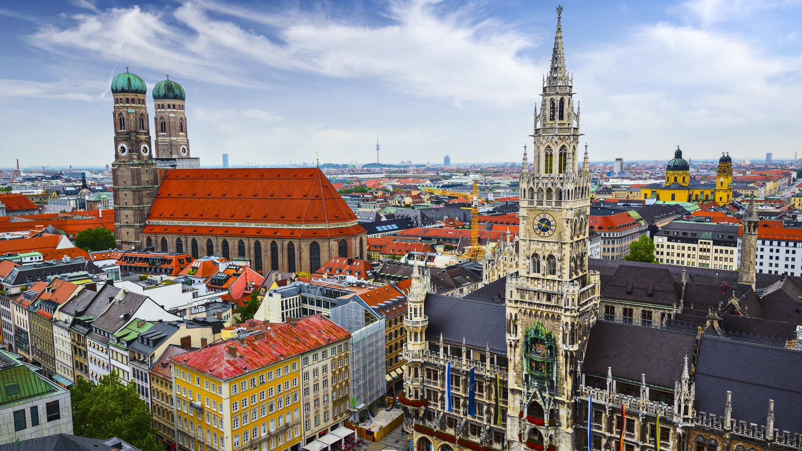

The German Studies minor focuses on the study of language, literature, history, culture, and cinema. A minimum of 6 units is required and one elective course may be taken in English. Students starting their German studies at a level higher than IT 107 will take more electives in order to complete the minor.

You may complete the German Studies minor abroad by taking approved elective classes in Germany, Austria or Switzerland. Studying abroad for a summer or a semester also fulfills the Intermediate Learning Community (ILC) requirement at Wagner. For more information, please see Ms. Ellen Navarro in the Center for Intercultural Advancement in Union 204.
FOUNDATION COURSES:

German 105: Basic Intensive German I

This course focuses on functional communication skills in listening, speaking, reading, writing and cross-cultural competence. Students work with authentic materials and contexts related to everyday life and culture, as well as interactive activities involving basic literature and short films to reinforce language use. Students’ personal interests will in part determine specific materials chosen, and participants will work on a final project related to their interests or studies. Three weekly contact hours plus audio-visual “lab” and homework. Pre-requisite: 0-2 years of high school instruction or permission of instructor. Students with more than two years of German or native speakers will not receive academic credit for this course. Offered fall semester.
German 106: Basic Intensive German II
German 106 continues the emphasis on functional communication skills in listening, speaking, reading, writing and cross-cultural competence initiated in GE 105. The course includes authentic materials related to everyday life and culture, and interactive activities with a significant focus on contemporary works of literature and film. Students’ personal interests will in part determine specific materials chosen, and participants will work on a final project related to their interests or studies. Three weekly contact hours plus audio-visual “lab” and homework. Pre-requisite: GE105, 1-2 years of high school instruction or permission of instructor. Students with more than two years of German require instructor’s permission. Native speakers will not receive academic credit for this course. Offered spring semester.
German 107: (Re) Discovering German: Accelerated Basic German
Why learn German? One in every four Americans has German heritage. Germany has the third largest economy in the world, and it is estimated that today German is spoken by 140 million people in Europe and across the world. This fast-paced course welcomes students with up to two years of previous high school experience to rediscover German at the college level. It is also appropriate for those who wish to discover the language for the first time. Designed for highly motivated learners, the course provides students with solid basic functional skills in speaking, listening, reading, writing, and cultural competence. The curriculum covers the fundamentals of German language use while introducing students to the cultures of Germany, Austria and Switzerland through interactive exercises, authentic texts, popular culture, and the visual arts. Pre-requisite: 0-2 years of high school instruction or permission of instructor. Students with more than two years of German require instructor’s permission. Native speakers will not receive academic credit for this course. Offered fall or spring semester.
German 111: Intermediate German I
In this course students will work toward solid intermediate-level proficiency while they gain a broader knowledge of the history and popular culture of the German-speaking world. The curriculum offers both a solid review and expansion of basic skills in listening, speaking, reading, writing and cultural competence, utilizing a variety of authentic materials from various regions of Germany, Austria and Switzerland. Students engage in extensive work with German-language literature and film as a vehicle for reinforcing communication skills in interpreting, discussing and presenting information. Three contact hours of class weekly plus audio-visual “lab” and homework. Pre-requisite: GE 106 or equivalent, or permission of instructor. Offered fall semester.
German 112: Intermediate German II
As a continuation of GE 111, participants will work with more advanced features of the language, utilizing authentic materials illustrating vocabulary in context, as well as important “high” and “low” cultural aspects of Germany, Austria and Switzerland. Linguistic work will focus on the ability to narrate, describe and explain, as well as on strategies for beginning to hypothesize and support opinion in an increasing number of contexts. German-language literature and cinema will be used as a vehicle for reinforcing communication skills, and students will also design a project relevant to their own personal interests or studies/major. Three contact hours of class weekly plus audio-visual “lab” and homework. Pre-requisite: GE 111 or equivalent, or permission of instructor. Offered spring semester.
German 231: Topics in German Cinema: Composition and Conversation I
What can film teach us about a country’s culture? In this class students will discuss both feature-length and short German-language films as the basis for understanding the history, society, culture, and national identity of German-speaking countries. Films will range from serious to comedic, from historical and documentary works to 21st century trends. Students will work on consolidating and improving advanced aspects of written and spoken German including narration and description, summarization, presentation, and discussion skills. Prerequisite: GE 112 or equivalent, or permission of instructor. Offered fall semester.
German 232: People, Politics and Pop! Composition and Conversation II
People – past and present, German, Austrian, and Swiss -- politics of all kinds, and culture – high and pop – will be the topics of this course. Students will strengthen their ability to converse and write about a wide range of people, events and values in contemporary society. Course materials will be drawn from written materials, film, music, and internet sources to create an integrated collage of contemporary issues tailored in part to participants' specific interests and studies. Students will continue to review advanced aspects of written and spoken German and improve their skills in understanding, interpreting and presenting information. Pre-requisite: GE 231 or permission of instructor. Offered spring semester.
ELECTIVES:

German 310: A Cultural Approach to Literature in German
This course will introduce connections across centuries through a variety of genres and disciplines, such as history, art, theater, music, film, and pop culture, by examining literature and other German cultural artifacts from a thematic vantage point. Major themes such as wars and the Holocaust, literature as provocation, literature and the arts, society and the individual, and the writer’s place in society Germany and Austria will be used to structure the course. Students will be exposed to the works of major authors, as well as those of some lesser-known names. Pre-requisite: German 232 or permission of the instructor. This class is open to native-speakers of German. Offered as needed.
ELECTIVES IN ENGLISH:

Modern Languages 316: International Filmmakers

How does film’s visual language bring us closer to a country’s culture?
This course examines the various representations of cultural traditions through the works of some of the most influential and thought-provoking international filmmakers. Directors include Chantal Akerman (Belgium), Jean-Pierre Bekolo (Cameroon), Icíar Bollaín (Spain), Nuri Bilge Ceylan (Turkey), Arturo Ripstein (Mexico), Michael Haneke (Austria), Chen Kaige (China), Abbas Kiarostami (Iran), Krzysztof Kieslowski (Poland), Akira Kurosawa (Japan), Lucrecia Martel (Argentina), Walter Salles (Brazil), Ousmane Sembène (Senegal), François Truffaut (France), Paolo Virzì (Italy), and others. Students interested in languages, foreign cultures and travel will gain a deeper understanding on the notion of “otherness” as seen through the works of award-winning filmmakers. Prerequisite: none. Offered as needed.

Art History 326: Cities and Perversities: Art in Turn-of-the-Century Paris, Vienna and Berlin (team-taught Intermediate Learning Community)
This course focuses on art in the fin-de-siècle in four major cosmopolitan centers: Paris, Vienna, Berlin, and Barcelona, with occasional stops in Belgium, Norway, and England. Styles discussed include Expressionism, Symbolism, Post Impressionism, Art Nouveau, and Jugendstil. The art of the period is explored in relation to issues of national identity c. 1900 and as a response to the shock of metropolitan life, a phenomenon experienced by artists in all four cities. These issues include attitudes toward sexuality, the rise of the crowd, alienation, the impact of psychoanalysis, escapism, and the withdrawal to the interior. We will also study the interrelation between painting, sculpture, architecture, design, and the popular arts in this period. The course attempts to understand better the shared visual language of turn-of-the-century Europe, while illuminating the special contributions and characteristics of the art of each city. Cross-listed as French 310. Offered as required.

English 310: Cities and Perversities: Literature in Turn-of-the-Century Paris, Vienna and Berlin (team-taught Intermediate Learning Community)
A detailed reading of some of the major literary works written in fin-de-siècle Paris, Vienna, Berlin, and Barcelona. Along with readings by authors such as Marcel Proust, Colette, Thomas Mann, Rainer-Maria Rilke, and Arthur Rimbaud, this class also addresses the rise of psychoanalysis, the exploration of sexuality, and café culture. Students will visit the Metropolitan Museum of Art and a concert at Carnegie Hall. Prerequisite: EN 212 or permission of instructor. Cross-listed as French 310. Offered as required.
History 334: Nazi Germany and the Holocaust
Study of the Nazi movement in Germany and Europe, from the post-World War I era to the Holocaust. Topics will include: Hitler’s ideas on race, religion and gender and their appeal; experiences of men and women in the Nazi State; the role of the church and big business; comparisons with Italian Fascism and Vichy France; Nazi persecutions, collaboration, and resistance; the Final Solution and the Jews. We will also analyze recent debates over the representation of this era in film, literature (including the comic book Maus), museum exhibits, and commemorative monuments. The course includes a trip to the National Holocaust Museum in Washington, D.C. Offered as required.
Philosophy 212: Hegel, Marx, and Nietzsche
This course examines the development of German philosophical thought from the late eighteenth century to the early twentieth century around the themes of idealism and materialism. Authors will include: Hegel, Fichte, Marx, and Nietzsche. Offered as required.
Philosophy 213: Existentialism
This course examines the important texts and central ideas of the major existentialist thinkers, Heidegger and Sartre, as well as those of important precursors such as Kierkegaard and Nietzche. Topics include the analysis of human reality ("the self" intentionality, consciousness, etc.), the relation of the individual to society, the basis of moral belief and decision, freedom, authenticity, self-deception, anxiety and the significance of death. Offered as required.

Philosophy 302: Philosophy and Psychoanalysis

Psychoanalysis remains one of a very few perspectives on human reality which continues to exert a major theoretical and practical influence around the world. This course examines a variety of topics and controversies introduced by Freud, his followers and his critics such as: the doctrine of unconscious mind, the object of desire (sexuality, aggression, love), the meaning of relationship, the extent of freedom, dreams and fantasy; narcissism; and madness, as well as issues pertaining to the nature of science and the foundations of psychology. Offered as required.

Religion 203: Spiritual Quest in Literature
An examination of some major pieces of fiction concerned with heroes on a search for meaning and purpose in their lives? Their search often leads them far from traditional religious beliefs. (Cross-listed as English 203). Offered either fall or spring semester. (This course includes several readings by German author Hermann Hesse)

* Please note that elective courses are not offered every year, so you must check the bulletin and plan accordingly. Additional electives may be approved on a case-by-case basis.

For more information on the German Studies minor please contact:

Professor Kathryn Buck, Campus Hall 205
kathryn.buck@wagner.edu

Professor Katica Urbanc, Parker Hall 303
kurbanc@wagner.edu

“Those who know nothing of foreign languages know nothing of their own.”

Johann Wolfgang von Goethe

Revised: 09/18

